Mayflower Homeschoolers
A Roman Catholic Independent Homeschool Support Group
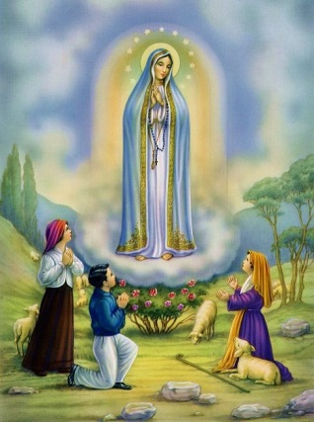

Under the Patronage of Our Lady of Fatima
www.mayflowerhomeschoolers.org

