Updated 10/23

https://www.mayflowerhomeschoolers.org

Mayflower Homeschoolers provides opportunities to break out of the house once a week or so for the sole purpose of developing friendships and support for all members of the family, including the parents. MH activities are social in nature, but are based in academics and The Faith. Therefore, participation in these activities can easily be integrated into one’s homeschool, instead of viewed as an addition. MH members often choose to complete their domestic and academic responsibilities over four weekdays, leaving the fifth day open to enjoy camaraderie and a slight change of homeschool pace via Mayflower activities.

We look forward to meeting you!

Under the Patronage of Our Lady of Fatima

# Mayflower Homeschoolers

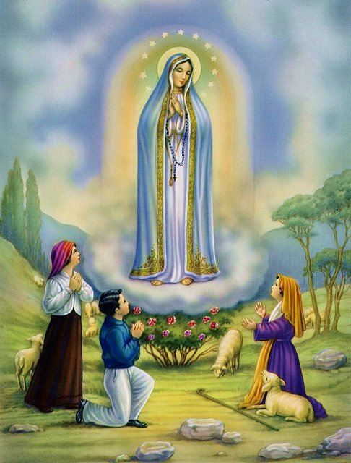

To Jesus through Mary.

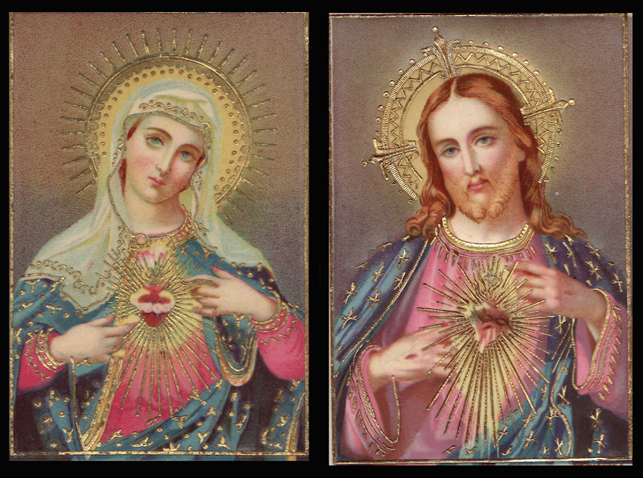



### Why We Are Here

[https://www.mayflowerhomeschoolers.org](http://www.mayflowerhomeschoolers.org)

 info@[mayflowerhomeschoolers.](mailto:mayflowerhomeschoolers@gmail.com)org

# Mayflower Homeschoolers

## **A Roman Catholic Multi-Chapter**

## **Homeschool Support Group**

Mayflower Homeschoolers (MH) is:

* Roman Catholic.
* Loyal to the Magisterium.
* Adherent to the unbroken tradition and teachings of the Roman Catholic Church.
* Adherent to the Principle of Subsidiarity (Parents have the exclusive right to make all decisions regarding their children, including their education).
* A simple group of homeschooling families.
* A homeschool support group.
* Spiritual and temporal support to families who homeschool.
* Weekly fellowship opportunities, if not more.
* Fellowship opportunities with a mix of spiritual, social, and academic activities.
* Independent.
* Currently, 3 local chapters (Richmond, Spotsylvania, and Warrenton) service Catholic homeschoolers in and around, but not limited to, the following Virginia counties: Culpeper, Fairfax, Fauquier, Frederick, Hanover, Henrico, Loudoun, Madison, Orange, Prince William, Rappahannock, Spotsylvania, Stafford, Warren, Westmoreland, as well as the Greater Richmond Area.

***May***flower, because May 13 is the Feast of Our Lady of Fatima, the patroness of Mayflower Homeschoolers.

#### **What We Do**

Members of MH commit to pray for the group every day. During the school year, our chapters offer the following similar activities in their region. Members enjoy the option to participate in the activities of any chapter:

* Clubs Day Monthly with Exposure to Religious Vocations as available.
* Mercy Day Monthly (Spiritual and Corporal Works of Mercy)-some feast day parties, some preceded by Latin Mass when possible.
* PE Day Monthly
* Field Trip Day Monthly
* Themed Teen Dances Quarterly
* 2 Academic Fairs Annually
* Family-Friendly Stations of the Cross Annually
* Marian Procession Semiannually
* May Crowning Annually
* Holy Baccalaureate Mass Annually
* Commencement Annually
* Moms Day/Night Out Monthly
* Couples Day/Night Out Quarterly
* Elizabeth Ministry as Needed
* Monthly Family Summer Fun Days (eg., beach days, etc.)
* Interested in starting a local chapter in your area? We’ll help you and its included in your membership!

#### **FAQs**

* *How do I join?*

Go to our website. Click “Request Membership” & complete the request form. We will contact you with more information.

* *What is required of members?*

Members commit to daily prayer for the group and an annual dues payment of $42 per family. In addition, service to this 100% volunteer group to help it function is highly desirable. Families are free to determine the amount of service which is peaceful for them.

* *Are there fees besides annual dues?*

At times, there could be nominal fees for individual activities.

* *Is membership in MH exclusive?*

No. With respect to the gift of free will given by God, and the Principle of Subsidiarity, MH members are free to make whichever choices they deem necessary for the education of their children, including membership in other homeschool support groups.

* *I’m not Roman Catholic. May I join?*

Yes. MH is open to all homeschoolers. However, to protect and nourish our Roman Catholic identity in all of our activities, membership in MH requires signing a mandatory Statement of Faith.

* *Must I participate in all activities?*

No. Adherent to the Principle of Subsidiarity, you choose the level of your participation.



May***flower*** for the flowers that we place in front of images of Our Lady, particularly during the month of May, in thanksgiving for her fiat which led to our salvation through her Son.



# Mayflower Homeschoolers

### Who We Are

 <https://www.mayflowerhomeschoolers.org> info@mayflowerhomeschoolers.org